Supplementary material

Model
Figure 1. Simplified representation of the Markov model.
The model starts with a Chagas disease patient in the upper left hand corner (Chronic Asymptomatic Chagas Disease), from here a patient may develop Chronic Chagas symptomatic heart disease (Right upper corner) or chronic symptomatic Digestive disease (bottom left corner). From All the three mentioned states a patient may die and transition to the fourth state, Death (bottom right corner). The model was stratified by age group and sex.

Starting populations
Starting populations were derived from the distribution of migrants from latin America provided by the Spanish National Institute of Statistics. Then The burden estimate of Chagas disease provided by Navarro et al. 2022 was used to calculate absolute numbers of cases of Asymptomathic Chronic Chagas disease.

Stratification
The data from the Spanish National Institute of Statistics was used to stratify the patients by age group and sex. Also, to keep the population constant over time, patients that outgrew the model where added to the first age group in the next time step.

Parameters of the model
- Probability of transitioning into state with cardiac Chagas disease.
The pre calibration value chosen from the literature was:
1.9% (95%CI, 1.3-3.0%) from Chadalawada et al. 2020.

- After calibration, it was 0.76%, and this was used in the final CEA analysis.
- In the OWSA analysis the 0.1-3.0% range was used.
- In the PSA analysis 0.7% was used as the mean of a Beta distribution, with a 95% CI 0.1-3%. The alfa and beta parameters were estimated using the method of moments.

- Mortality due to Chagas cardiac disease.
A relative risk was used, to calculate the mortality risk of patients with cardiac disease, on top of the baseline population mortality. This relative risk was derived from the literature by dividing the yearly mortality rate reported by Chadalawada et al. 2023 6.3% (95% CI 4.9-8), by the yearly population mortality of the 50-55 year group, yielding 12 (95% CI 8-16).
- After calibration it was 9.6.
- In the OWSA the range used was 8-16.
- in the PSA 9.6 was used as a mean and 8-16 as the 95% CI of a lognormal distribution.
- Mortality due to Chronic Chagas digestive disease
A relative risk was used and estimated taking the values referred by Cubunuba et al. 2016. 2.1, 95% CI 1.52-2.91.
- After calibration best value was 2.09.
- In the OWSA the range used was 1.5-2.91.
- In the PSA 2.09 was used as a mean and 1.5-2.91 as the 95% CI of a lognormal distribution.

- Probability of transitioning into state with Chagas digestive disease.
The pre-calibration value chosen from the literature was: 1.1% (CI 95%, 0.8-1.36), derived from the data of Castro et al. 1994.
- After calibration it was 1.9%.
- In the OWSA the range used was 0.8-2%.
- In the PSA 1.9% was used as the mean of a Beta distribution and 0.8-2% as the 95% CI. Alfa and beta were estimated using the method of moments.

- Relative risk reduction of progression to Cardiac Chagas disease
The value chosen from the literature was: 0.49 (CI 95%, 0.19-1.25), Crespillo-Andújar et al. 2022. This is not a calibrated parameter.
- In the OWSA the range used was 0.19-1.25.
- In the PSA 0.49 was used as a mean and 0.19-1.25 as the CI of a lognormal distribution.

- Relative risk reduction of progression to Digestive Chagas disease

The value chosen from the literature was: 0.88 (CI 95%, 0.55-1.42), Pellison et al. 2022. This is not a calibrated parameter.
- In the OWSA the range used was 0.55-1.42.
- In the PSA 0.88 was used as the mean and 0.55-1.42 as the 95% CI of a lognormal distribution.

Calibration results
To calibrate the model the parameters were given probability distributions, and the model was run 100000 times, Deaths due to Chagas Cardiac disease was compared to Deaths reported by Ramos-Rincón et al. The sum of the mean squared difference of the point estimates of the model output and the published data reported where used to choose the best simulation and thus the set of parameters that best fit the data. The mean squared difference was 9.02.
The best parameters were:
Probability of developing Cardiac Chagas disease: 0.0076.
Relative Risk of Chagas cardiac disease mortality: 9.6
Relative risk of Chagas digestive disease mortality: 2.09
Probability of developing digestive Chagas disease: 0.019

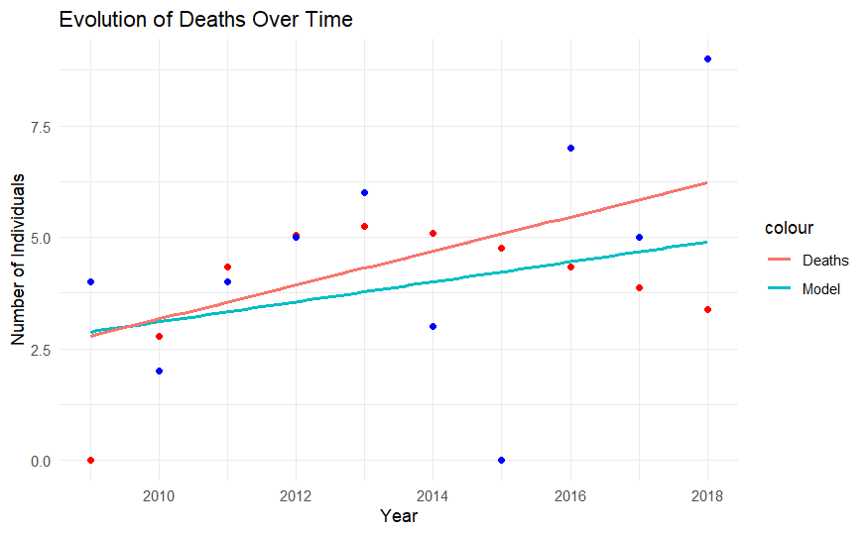
Representation of published data (in blue) and modelled data (in red) (from Ramos-Rincón et al). Lines represent linear regression lines.

Costs

We estimated costs for the different states as follows:
Chronic Asymptomatic state, treated.

Item | Unit Cost (€) | Annual Units | Annual Cost (€)
Treatment | 131.00 | Once | 7.00
Complete Blood Count (CBC) | 10.00 | 2 | 20.00
Basic Biochemistry | 20.00 | 2 | 40.00
ECG | 40.00 | 2 | 80.00
Echocardiogram | 100.00 | 0.05 | 5.00
Trypanosoma cruzi Serology | 20.00 | 2 | 40.00
Trypanosoma cruzi PCR | 44.26 | 2 | 88.52
Cardiac Pacemaker (MCP) | 6,000.00 | 0 | 0.00
Heart Transplant | 100,000.00 | 0 | 0.00
Implantable Cardioverter Defibrillator (ICD) | 25,000.00 | 0 | 0.00
Ventricular Assist Device (VAD) | 60,000.00 | 0 | 0.00
Barium Enema | 80.00 | 0.05 | 4.00
Barium Esophageal Transit Study | 90.00 | 0.05 | 4.50
Gastroscopy | 150.00 | 0 | 0.00
Medical Consultation | 98.00 | 2 | 196.00
Total |  |  | 478.02

Item | Unit Cost (€) | Annual Units | Annual Cost (€)
Complete Blood Count (CBC) | 10.00 | 2 | 20.00
Basic Biochemistry | 20.00 | 2 | 40.00
ECG | 40.00 | 2 | 80.00
Echocardiogram | 100.00 | 1 | 100.00
Trypanosoma cruzi Serology | 20.00 | 2 | 40.00
Trypanosoma cruzi PCR | 44.26 | 2 | 88.52
Cardiac Pacemaker (MCP) | 6,000.00 | 0.02 | 120.00
Heart Transplant | 100,000.00 | 0.01 | 1,000.00
Implantable Cardioverter Defibrillator (ICD) | 25,000.00 | 0.03 | 750.00
Ventricular Assist Device (VAD) | 60,000.00 | 0 | 0.00
Barium Enema | 80.00 | 1 | 80.00
Barium Esophageal Transit Study | 90.00 | 1 | 90.00
Gastroscopy | 150.00 | 1 | 150.00
Medical Consultation | 98.00 | 2 | 196.00
Sacubitril/Valsartan | 705.21 | 12 | 8,462.52
Bisoprolol | 5.93 | 12 | 71.16
Dapagliflozin | 46.02 | 12 | 552.24
Furosemide | 2.25 | 12 | 27.00
Hospitalization | 2,727.32 | 0.04 | 109.09
Total |  |  | 11,976.53

Item | Unit Cost (€) | Annual Units | Annual Cost (€)
Complete Blood Count (CBC) | 10.00 | 2 | 20.00
Basic Biochemistry | 20.00 | 2 | 40.00
ECG | 40.00 | 2 | 80.00
Echocardiogram | 100.00 | 1 | 100.00
Trypanosoma cruzi Serology | 20.00 | 2 | 40.00
Trypanosoma cruzi PCR | 44.26 | 2 | 88.52
Cardiac Pacemaker (MCP) | 6,000.00 | 0 | 0.00
Heart Transplant | 100,000.00 | 0 | 0.00
Implantable Cardioverter Defibrillator (ICD) | 25,000.00 | 0 | 0.00
Ventricular Assist Device (VAD) | 60,000.00 | 0 | 0.00
Barium Enema | 80.00 | 1 | 80.00
Barium Esophageal Transit Study | 90.00 | 1 | 90.00
Gastroscopy | 150.00 | 1 | 150.00
Esophageal Manometry | 1,955.00 | 0.05 | 97.75
Surgery | 6,277.00 | 0.01 | 62.77
Endoscopic Sphincterotomy | 978.00 | 0.01 | 9.78
Medical Consultation | 98.00 | 2 | 196.00
Total |  |  | 858.82

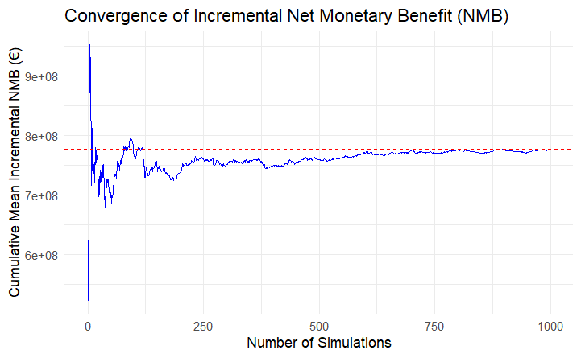

Figure: Convergence plot of the cumulative mean incremental Net Monetary Benefit (NMB) over the number of probabilistic sensitivity analysis simulations. The red dashed line indicates the overall mean incremental NMB. The plot suggests that the estimate stabilizes after approximately 700–800 simulations, supporting the adequacy of the chosen sample size for decision-making.
1 Consejería de salud. Orden de 24 de mayo de 2024, por la que se establece el importe de los servicios, actividades y bienes de naturaleza sanitaria, prestados en centros sanitarios del Sistema Sanitario Público de Andalucía, que deben ser retribuidos mediante precios públicos por los terceros obligados legalmente al pago. Bol Of Junta Andal 2024; : 1–163.
2 Ministerio de Ciencia e innovación. Resolución de 14 de noviembre de 2023, del Instituto de Salud Carlos III, O.A., M.P., por la que se modifica el Anexo de la Resolución de 3 de abril de 2019, por la que se establecen los precios públicos correspondientes a la prestación de servicios y actividades del organismo. Bol Of Estado 2023; published online Dec 5.

